**Maharishi University of Management**

**CS522 – Big Data**

**Dr. Premchand Nair**

**Set Up a Single Node Cluster using VM or Docker**

Table of Contents

Creating a Hadoop Project 3

Include Hadoop Jar files to project 3

Change the Java Execution Environment 5

Copying WordCount Example from Wiki and Exporting JAR 6

Using Cloudera Quickstart VM 9

Download Cloudera 9

Download Virtual Box 9

Using Docker 15

Install Docker 15

Install Hadoop Image on Docker 15

Sharing files (JAR and Input Files) between your machine and the Docker container 16

Executing Hadoop commands using Docker 17

Creating the Directory Structure inside HDFS 18

Running the Hadoop Application using the JAR file 19

Add logging (Debugging) Hadoop 21

Running multiple MapReduce tasks 25

# Creating a Hadoop Project

Open Eclipse and Start a New Java Project.

If you want to use Cloudera Quickstart VM way, follow the steps to install it first at Using Cloudera Quickstart VM before following this chapter.

## Include Hadoop Jar files to project

Download Hadoop Common and Hadoop MapReduce Client Core jar files from below links:

<http://mvnrepository.com/artifact/org.apache.hadoop/hadoop-common/2.7.3>  
<http://mvnrepository.com/artifact/org.apache.hadoop/hadoop-mapreduce-client-core/2.7.3>

Add those JAR files to your Project

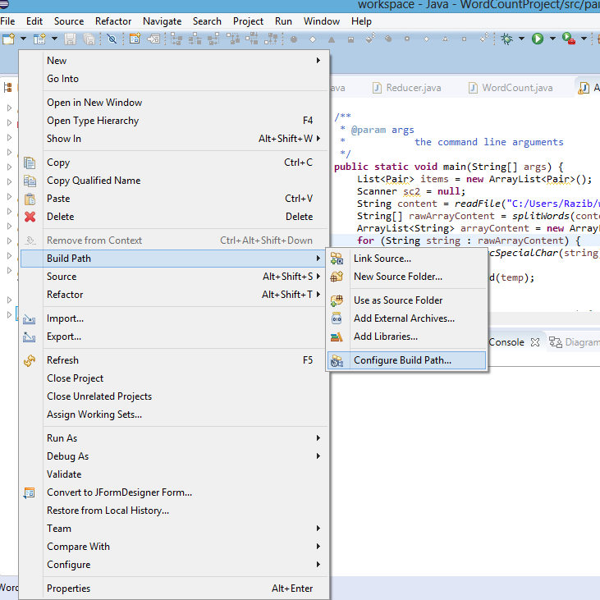

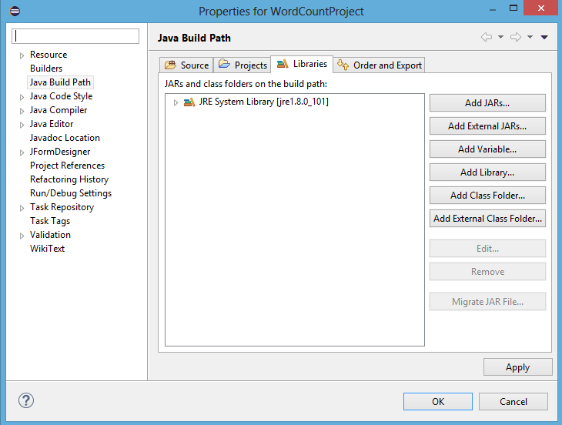

## Change the Java Execution Environment

To be able to run the Jar file inside Hadoop, make sure you change your Java Environment to JDK 1.7

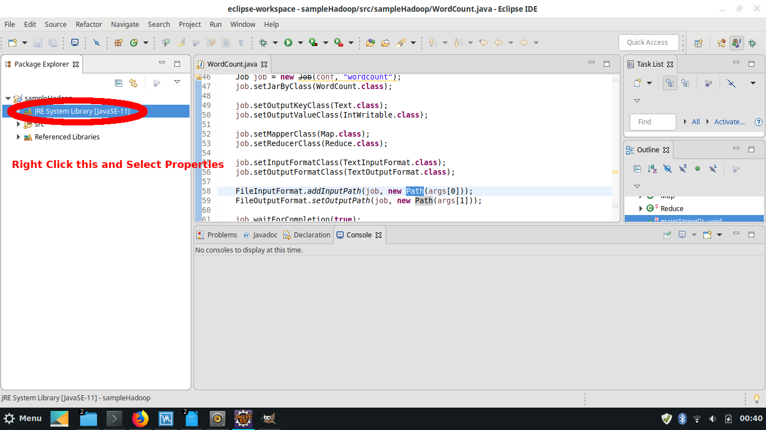

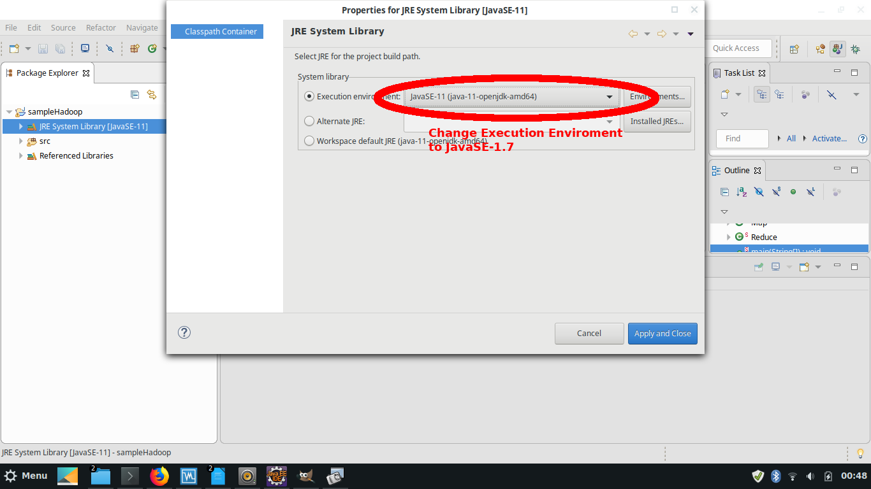

## Copying WordCount Example from Wiki and Exporting JAR

Get WordCount example from <https://wiki.apache.org/hadoop/WordCount>

AFTER THIS LINE IN THE CODE

Job job = new Job(conf, "wordcount");

ADD

job.setJarByClass(WordCount.class);

Export to WordCount.jar to test the WordCount example. Right click on Project, choose “Export”. The Export window will appear, choose Java -> JAR file. Click Next.

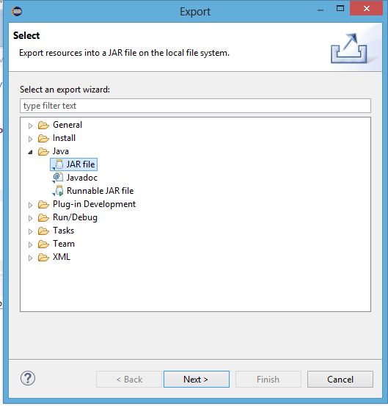

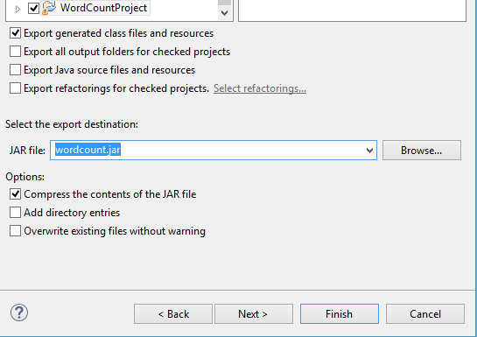

After these steps, your JAR file is complete. Make sure you know its location as it is going to be important on the next steps.

Now you can choose either the VM approach using Cloudera Quickstart or the Hadoop Docker Container approach.

# Using Cloudera Quickstart VM

## Download Cloudera

**Cloudera stopped supporting. I have their last version. If you need please contact me.**

## Download Virtual Box

from <https://www.virtualbox.org/wiki/Downloads>

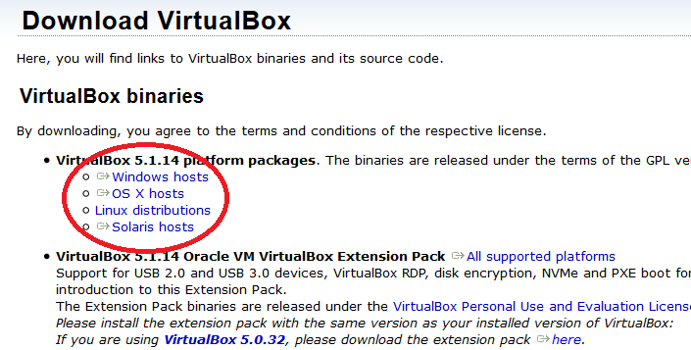

Click on File > Import Appliance

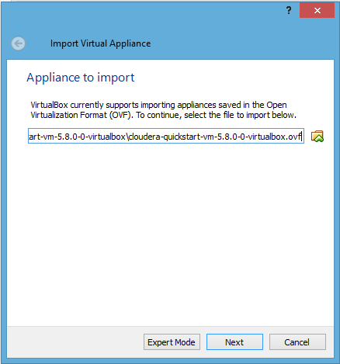

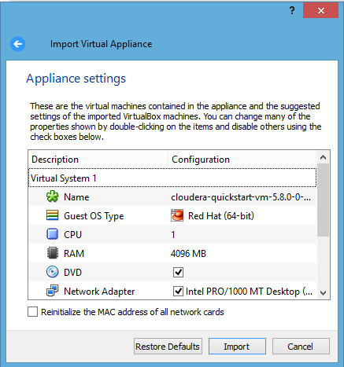

To enable network access go to Machine > Settings > Network and choose NAT in Attached to option as below:

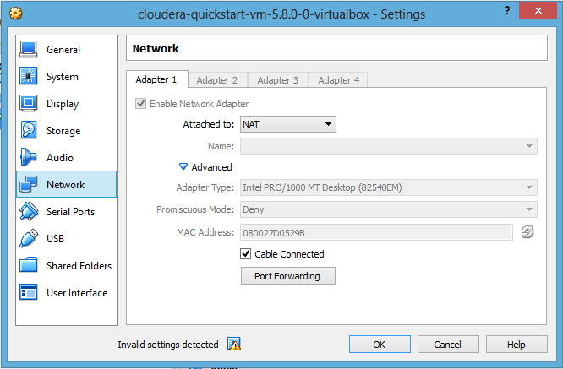

Now start Cloudera VM by clicking start button:

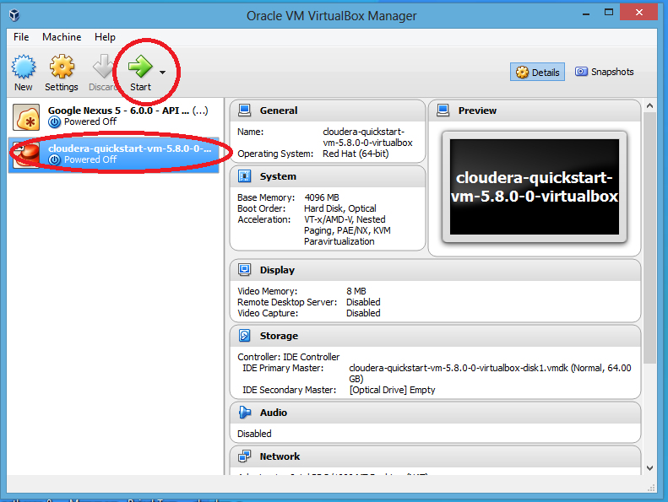

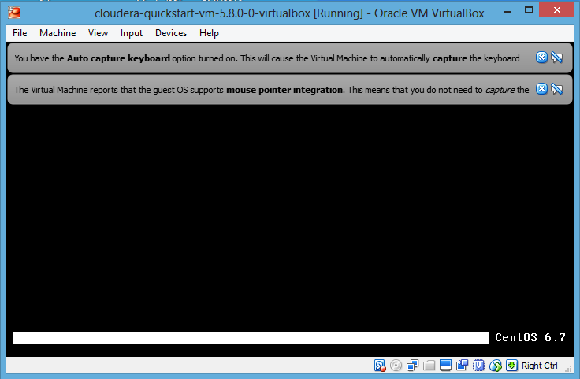

Desktop will look like below:

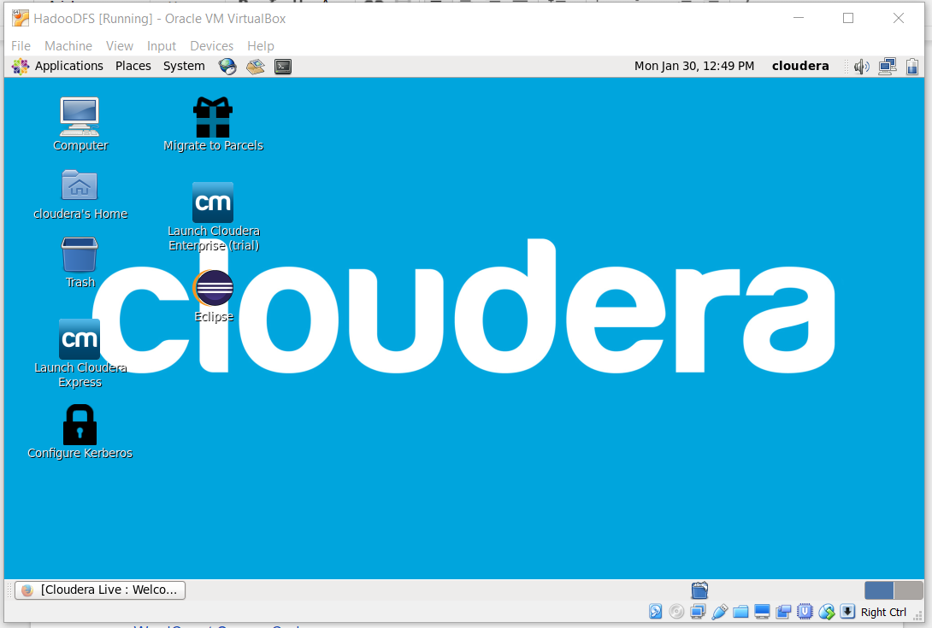

Open terminal program:

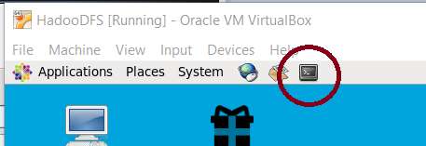

After these steps, your Cloudera Environment is ready and you can skip to Creating the Directory Structure inside HDFS

# Using Docker

## Install Docker

First install Docker on your machine using the instructions from official website:  
<https://docs.docker.com/install/>

After installing it, check if Docker is installed correctly opening your terminal and typing the following command:

$ docker -v

It should return something like this (it can be another version, make sure yours is equal or greater than 18):

Docker version 18.09.7, build 2d0083d

If this is OK proceed to the next step, if it isn’t, try to reinstall Docker.

## Install Hadoop Image on Docker

Use the following command to pull the image to your docker machine:

# docker pull sequenceiq/hadoop-docker

Attention! Each time you see a # before a command, it means you have to run that command as a superuser (root user). That user is very similar to an Administrator account in Windows. If you receive permission denied error, try to run using sudo before the command. For example, if you want to run docker pull sequenceiq/hadoop-docker and it results in permission denied, try to run sudo docker pull sequenceiq/hadoop-docker instead. If this doesn’t work on your Linux Distribution try to search on the internet how to run a command as administrator in that distribution.

After pulling the image, try to start the container using the following command:

# docker run -it sequenceiq/hadoop-docker:2.7.0 /etc/bootstrap.sh -bash

The above command output should be something similar to this:

edgar@edgar-Aspire-A515-41G:~/eclipse/jee-2019-06/eclipse$ sudo docker run -it sequenceiq/hadoop-docker /etc/bootstrap.sh -bash

/

Starting sshd: [ OK ]

Starting namenodes on [efea29053abf]

efea29053abf: starting namenode, logging to /usr/local/hadoop/logs/hadoop-root-namenode-efea29053abf.out

localhost: starting datanode, logging to /usr/local/hadoop/logs/hadoop-root-datanode-efea29053abf.out

Starting secondary namenodes [0.0.0.0]

0.0.0.0: starting secondarynamenode, logging to /usr/local/hadoop/logs/hadoop-root-secondarynamenode-efea29053abf.out

starting yarn daemons

starting resourcemanager, logging to /usr/local/hadoop/logs/yarn--resourcemanager-efea29053abf.out

localhost: starting nodemanager, logging to /usr/local/hadoop/logs/yarn-root-nodemanager-efea29053abf.out

bash-4.1#

Leave that Terminal Window alone for now, that is the terminal for the Hadoop Docker Container.

To check if everything is OK, open another terminal window and type:

# docker ps

The expected output should be:

edgar@edgar-Aspire-A515-41G:~/eclipse/jee-2019-06/eclipse$ sudo docker ps

CONTAINER ID IMAGE COMMAND CREATED STATUS PORTS NAMES

efea29053abf sequenceiq/hadoop-docker "/etc/bootstrap.sh -…" 7 minutes ago Up 7 minutes 2122/tcp, 8030-8033/tcp, 8040/tcp, 8042/tcp, 8088/tcp, 19888/tcp, 49707/tcp, 50010/tcp, 50020/tcp, 50070/tcp, 50075/tcp, 50090/tcp silly_beaver

## Sharing files (JAR and Input Files) between your machine and the Docker container

For us the be able to run Hadoop commands, like hadoop jar, we need to copy some files from our local machine to that Docker Container containing Hadoop. To do this, you have to know its Container ID as it is randomly generated each time you run it. To see it, run docker ps as was shown above (in the example above the Container ID was efea29053abf).

When you know your docker id you can upload your jar file using the following command (REPLACE efea29053abf with your Container ID and JarFileLocation with your real Jar File Location in your machine!):

# docker cp JarFileLocation efea29053abf:/usr/local/hadoop

The above command copies the file JarFileLocation from Local Machine to folder */usr/local/hadoop* inside the Docker Container with ID efea29053abf*.*

With this, you can also copy any file from your machine to the container, not just the jar.

## Executing Hadoop commands using Docker

Once you are done with the above commands, you can run any Hadoop command **inside the container terminal.**

First we change our current directory to the Hadoop directory

$ cd /usr/local/hadoop

Then we can execute hadoop commands using bin/hadoop, for example:

$ bin/hadoop fs -mkdir /user/cloudera

PS: Don’t forget that the command in this Docker Container is bin/hadoop, not just hadoop!!

In this setup, each time you terminate the Docker Container all your modifications to the HDFS are lost and you have to repeat all those steps!

# Creating the Directory Structure inside HDFS

Open Terminal and first create input locations in HDFS. Using the following commands:

hadoop fs -mkdir /user/cloudera /user/cloudera/wordcount /user/cloudera/wordcount/input

We also have to send files to the input folder. We can do using the following commands.

echo "Hadoop is an elephant" > file0

echo "Hadoop is as yellow as can be" > file1

echo "Oh what a yellow fellow is Hadoop" > file2

hadoop fs -put file* /user/cloudera/wordcount/input

With these commands we are creating three files named file0, file1 and file2 and sending them to the HDFS folder /user/cloudera/wordcount/input using hadoop fs -put.

Attention: The output folder is going to be created by the JAR Application by the time you run it with Hadoop, don’t create it manually or else it is going to fail.

# Running the Hadoop Application using the JAR file

Run the WordCount application from the JAR file we created on Eclipse, giving the paths to the input and output directories in HDFS.

hadoop jar wordcount.jar org.myorg.WordCount /user/cloudera/wordcount/input /user/cloudera/wordcount/output

(Make sure that the package name org.myorg is the same as you used on your project! Change it if it is different.)

The output should be as following:

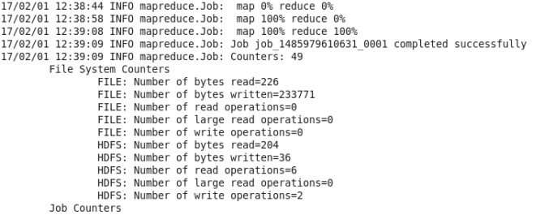

In order to see the output use the following command which will be as follows or you can see from the browser (<http://ipAddressOfHadoopMachine:50070/explorer.html#/>) by downloading the output file.

hadoop fs -cat /user/cloudera/wordcount/output/*

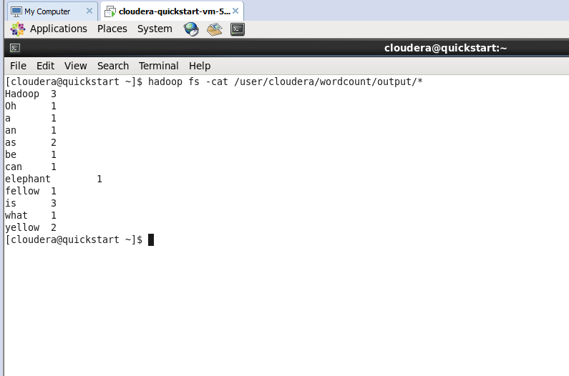

If you want to run the sample again, you first need to remove the output directory. Use the following command.

hadoop fs -rm -r /user/cloudera/wordcount/output

**Hadoop setup is complete. Continue only if you want to debug Hadoop.**

# Add logging (Debugging) Hadoop

1. Hadoop uses log4j by default. Firsts step is to configure its settings:
   1. Add **resources** folder to your project. Then, add **log4j.properties** file to that folder

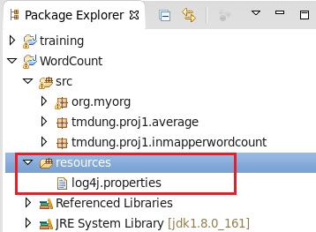

* 1. Open log4j.properties file and add the following settings:

log4j.rootLogger=DEBUG, CA

log4j.appender.CA=org.apache.log4j.ConsoleAppender

log4j.appender.CA.layout=org.apache.log4j.PatternLayout

log4j.appender.CA.layout.ConversionPattern=%-4r [%t] %-5p %c %x - %m%n

1. Add code to log the info we need:
   1. Create Logger instance:
      1. private Logger logger = Logger.getLogger(MyMapper.class);
   2. Use respective log methods for your purpose:
      1. logger.info("Log information");
      2. logger.error("Log some error");
      3. logger.debug("Debug information");
2. Sample:

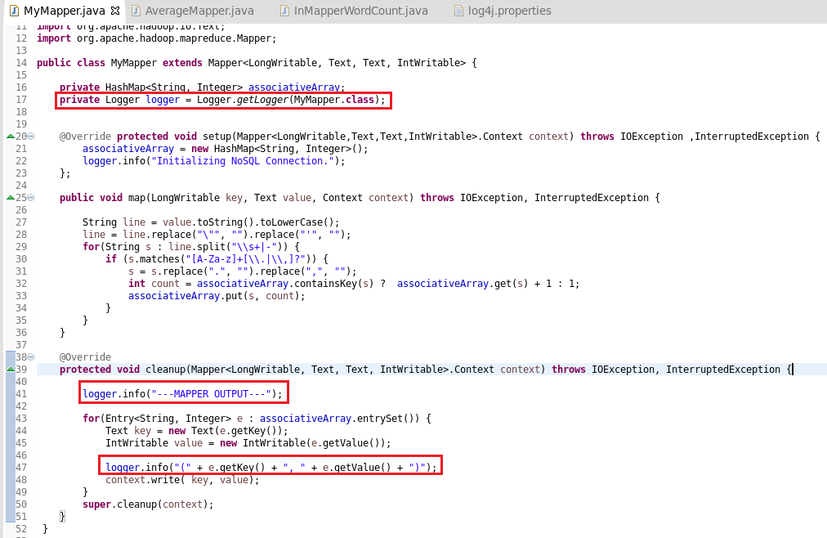

1. View logs:
   1. The logger will by default write log to Hadoop tracker system’s log file.
   2. One way to see it is open [http://quickstart.cloudera:8088/proxy/<application_ID>/](http://quickstart.cloudera:8088/proxy/%3capplication_ID%3e/) in browser if you use Cloudera Quickstart VM or <http://IP_OF_DOCKER_CONTAINER:8088/proxy/><application_ID>/ if you use Docker.
   3. Select Map Tasks on left menu

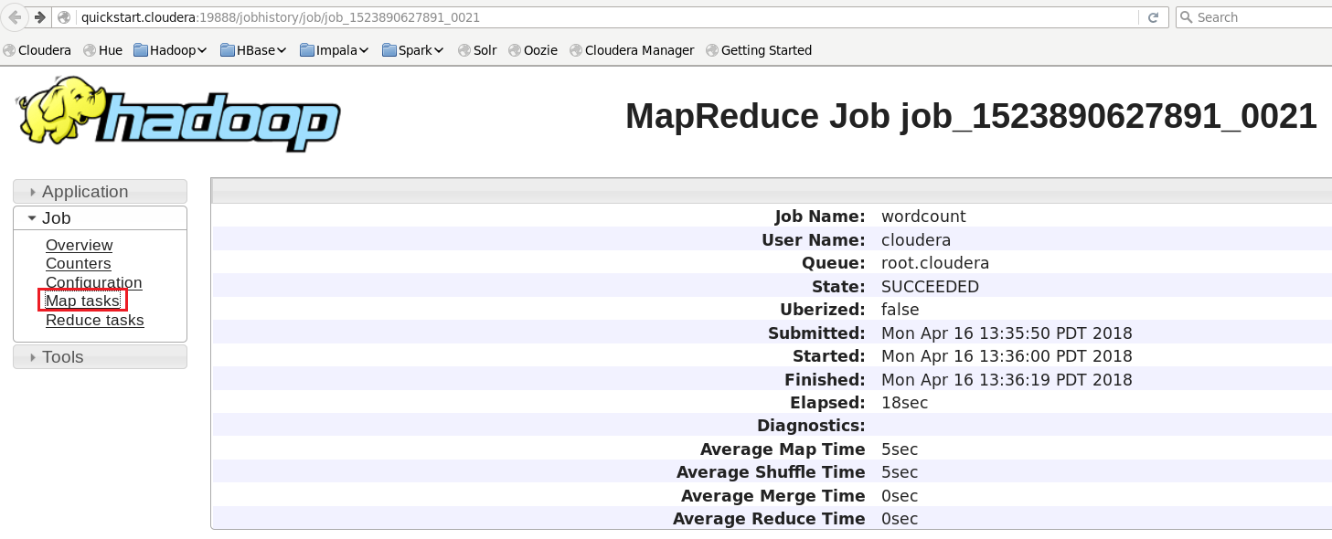

* 1. Select on the task link:

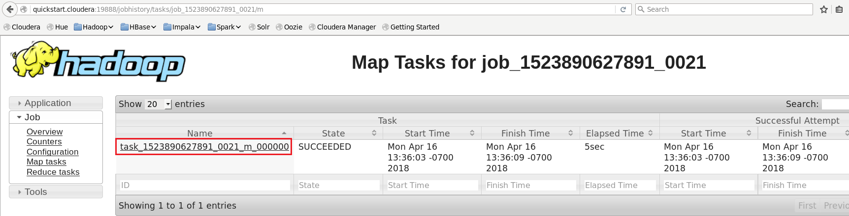

* 1. Select logs:

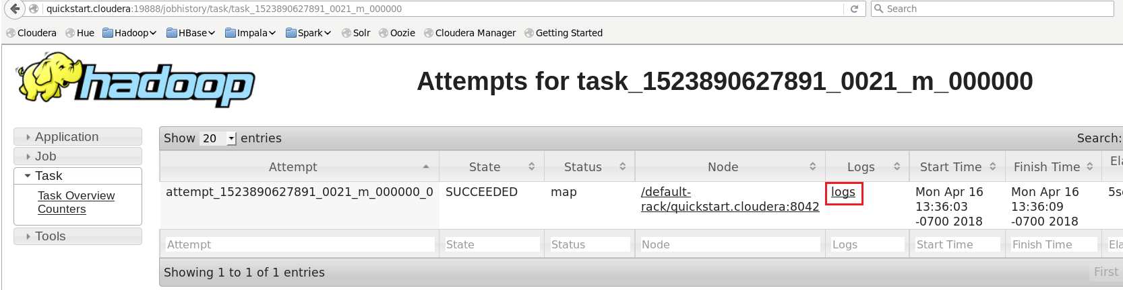

* 1. You can see the content of logging in syslog section:

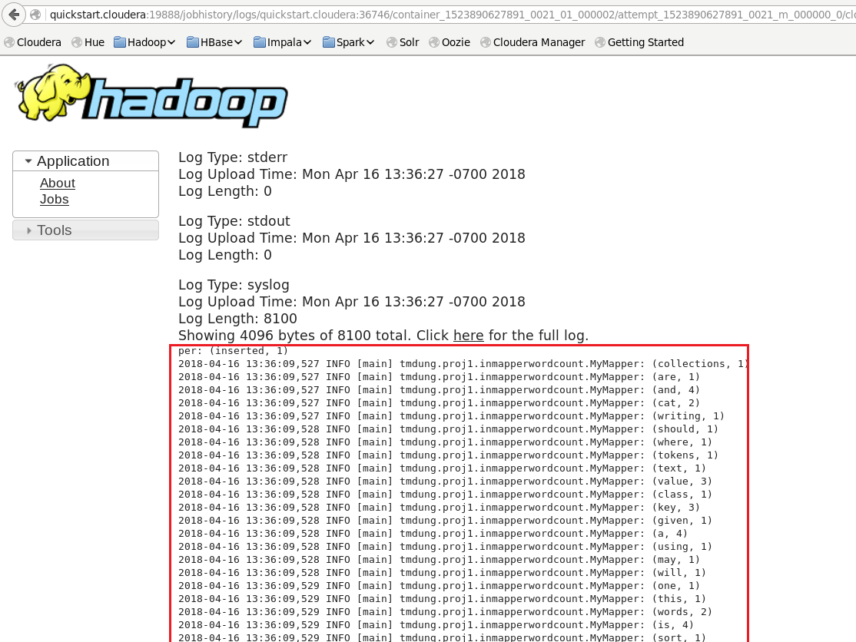

End

# Running multiple MapReduce tasks

Option 1:

<https://coe4bd.github.io/HadoopHowTo/multipleJobsSingle/multipleJobsSingle.html>

Option 2:

Use Oozie

<http://oozie.apache.org/>